Relations Between Illumination conditions and Image

It with the same theory for take a picture from a camera or a camera module, gather light thru lens and pass to Sensor, after decoded by DSP , So as to obtain a colorful and clear picture. But when the camera towards sunlight straightly, Strong sunlight will confluence to the sensor chip, it will damage the sensor in long time. It is often heard that the camera was damage during take picture for solar eclipse.
When sunlight is at rear side of objective, then it is called smooth shooting environment when take pictures. But if the shooting angle is not correct, it is easy produce such as ghosting or flare or over explore，make a picture seems dark, if the picture used for face recognition, it may cause failed.
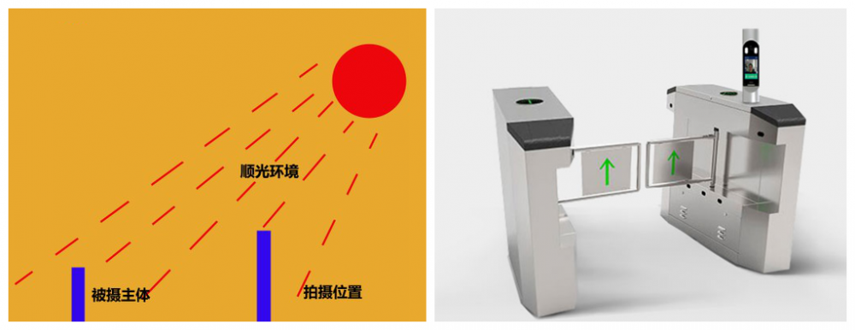
Backlight shooting and Smooth shooting
Smooth shooting：That mean sunlight and lens in the same direction, the picture taken under this condition will be much better the backlight shooting
Backlight shooting：sunlight and lend in different direction. Picture taken under this condition will be dark.

