Relations between Focus and Depth of Field
Definitions ：
1、focus
When the parallel light get thru a Convex lens，it will focus on a point and then diffused after that point, we called that point Focus .
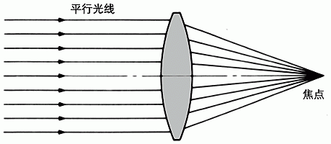

2、circle of confusion
Just around the focus，light will become focus or diffuse, image will be blurry, this form a circle, which we call it circle of confusion
In reality, when we see a picture/image, it will be projected or zoomed. We will see different result of a picture with different distance or Magnification .if the diameter of circle of confusion smaller than human eye discrimination，the image blurry will be ignore. This discrimination circle is called permissible circle of confusion.
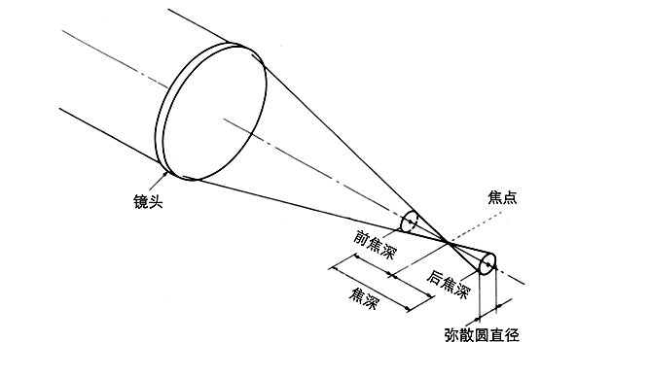
Different manufacture of lens has different values for the permissible circle of confusion, the most popular is :
 | 24mm x 36mm | 6cm x 9cm | 4" x 5"
 | 0.035mm | 0.0817mm | 0.146mm

3、depth of field
There is a permissible circle of confusion at front and rear side of focus, the distance between front permissible circle of confusion and rear side permissible circle of confusion is called depth of field. That means the objective distance can be a range instead fixed at a point.
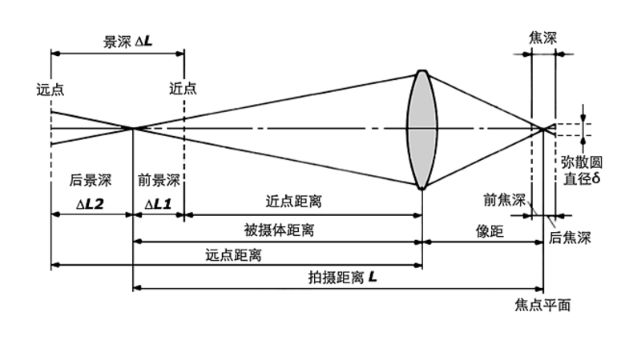
The depth of field is varied from focus value, Aperture value(F no.)、distance of objective。If focus and objective distance is fixed, the smaller Aperture value, the bigger depth of field.
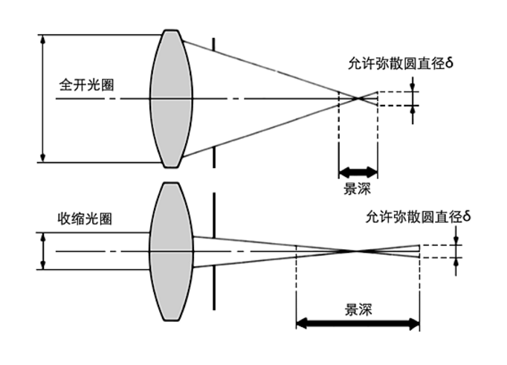 8
The farthest objective distance to focus to make a clear picture we called it front depth of field, and the closest objective distance to focus we called rear depth of field
4、formula for depth of field
Below is the formular for depth of field：
δ | —— | Diameter of permissible circle of confusion
f | —— | Focus distance
F | —— | Lens aperture value
L | —— | Shooting distance
ΔL1 | —— | Front depth of field
ΔL2 | —— | Rear depth of field
ΔL | —— | Depth of field

FδL2
Front depth of field ΔL1=
f2 + FδL

 | FδL2
Rear depth of field ΔL2= | ——————
x7 {! ]+ U. j$ |3 Z | f2 - FδL

 |  | 2f2FδL2
Depth of field ΔL= | ΔL2 + ΔL2=
7 ]! N* h, K" Z. ?) [6 K |  | f4 - F2δ2L2

From the formular we know that front depth of field>rear depth of field
From the formular we can conclusion as depth of field is related with aperture value, focus, objective distance and the quality requirement for picture. All those factor relationship as below：
(1)、Aperture value：
The bigger aperture value, the shorter depth of field. vice versa.
(2)、Focus
The longer lens focus, the shorter depth of field, vice versa
(3)、Objective distance
The longer objective distance, the longer depth of field, vice versa.

δ | = | 0.035mm
f | = | 200mm
F | = | 2.8
L | = | 5000mm
ΔL1 | = | 60mm
ΔL2 | = | 62mm
ΔL | = | 122mm
Conclude | ： | when use f/2.8 take picture，objective distance should be 4.94m~5.062m, it is a short depth of field

